Note that my code was written in octave, and each question part has a separate file.

7.5

a.

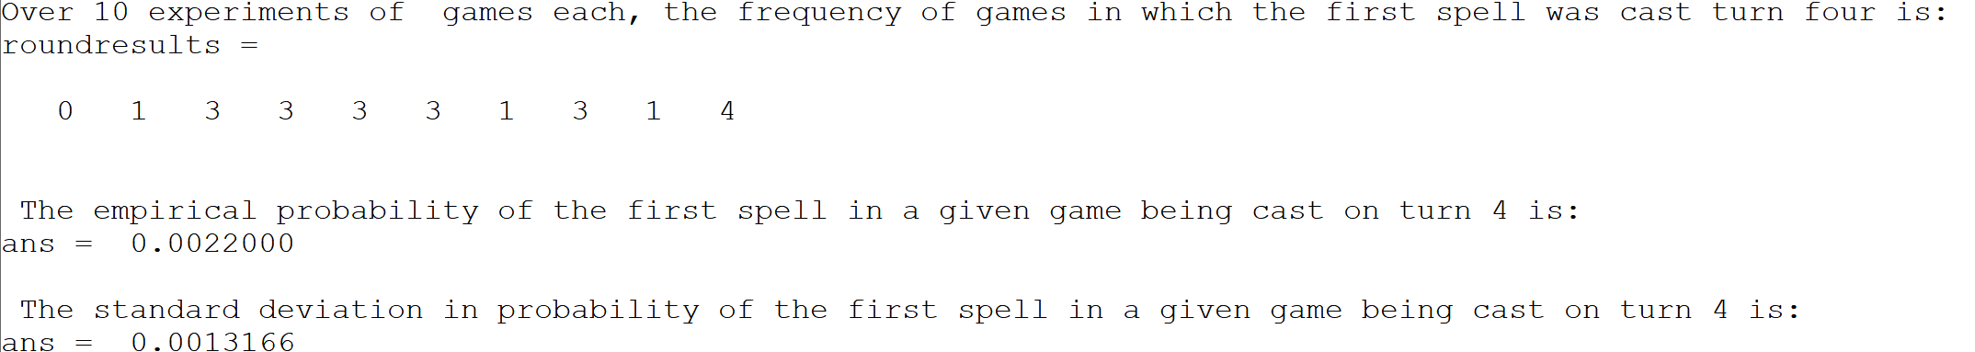The empirical probability of the first spell cast in any given game has a cost of 4 is .0022, or .22%. This result is pretty small. The standard deviation in the probability was .00132.

b.

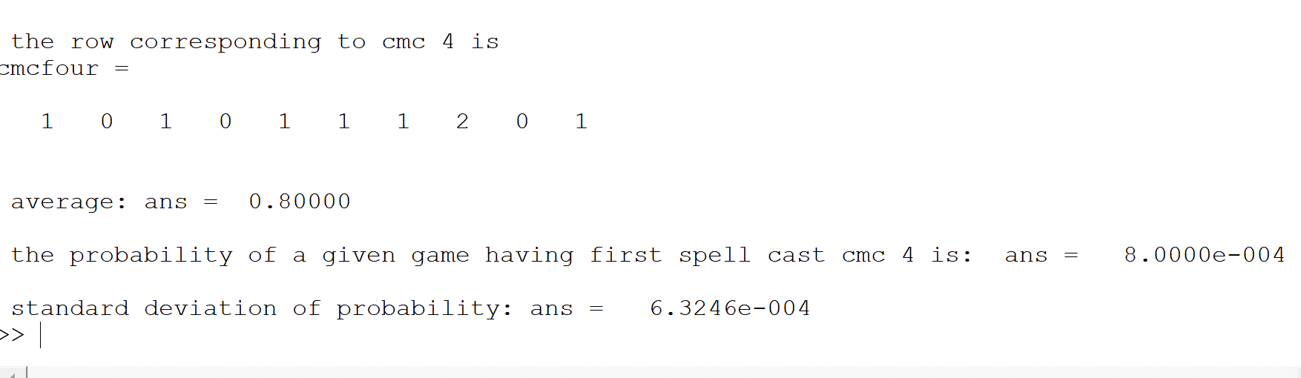

The empirical probability of the first spell cast having a cost of 4 is .0008, or .08%. This result is very small, and subject to a relatively high amount of variance, as indicated by the standard deviation of .00063, which is 79% of the mean. This is likely due to the low probability of the event occurring, making the outcome counts very low: zero, one or two. As such, the weak law of large numbers isn’t particularly accurate. Making each experiment have 50000 games, for instance, would likely make it more consistent.

c.

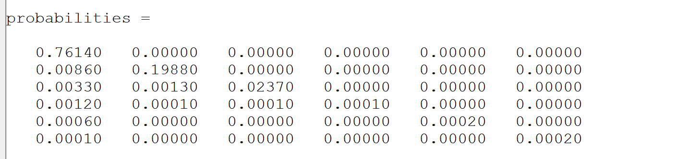

Horizontal index is spell cost, vertical index is turn number

7. 6

a. 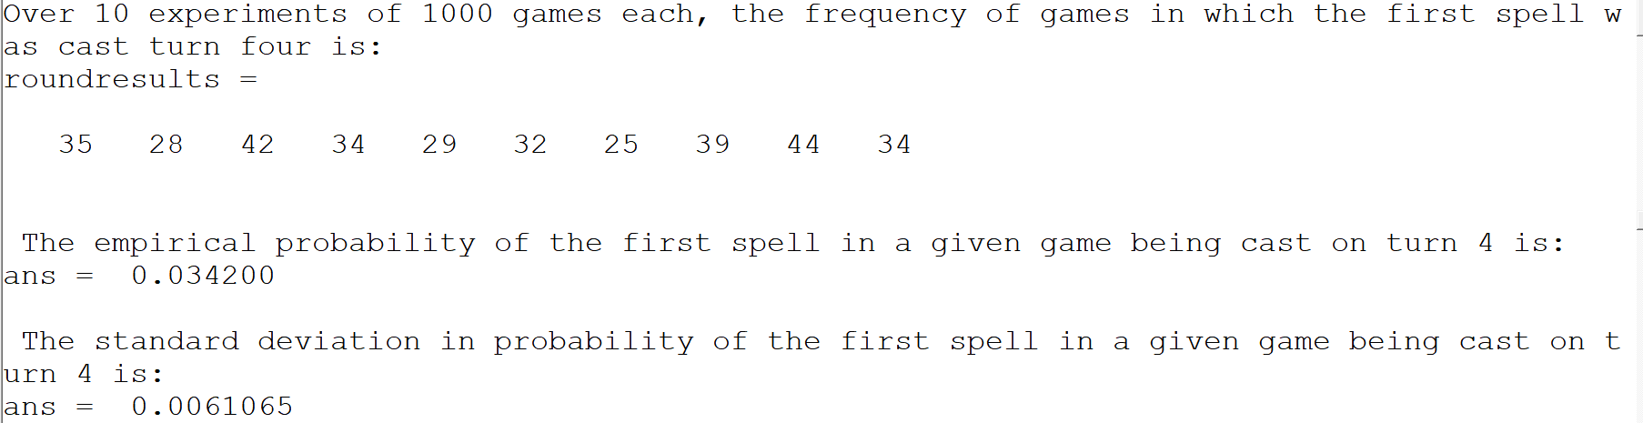

The empirical probability of the first spell being cast on turn 4 was .0342, or 3.4%. This result is significantly higher than found in the previous question, likely because the number of lands in the deck was reduced. The standard deviation in this probability was .0061.

b. 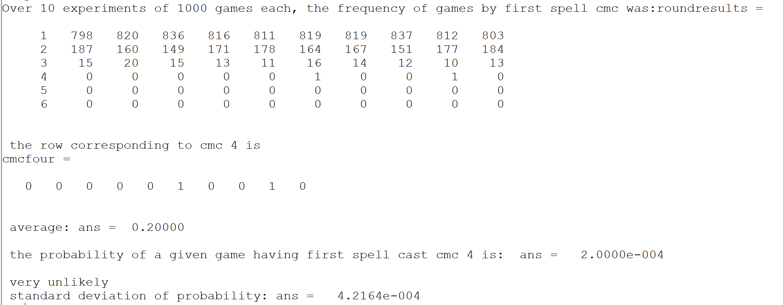

The probability of the first spell cast having cost 4 is .0002, or .02%. This is a decrease from 7.5b, which is to be expected because having fewer lands makes it less likely that you will cast expensive spells. However, due to the still high standard deviation (twice the value of the probability itself), it’s hard to draw a definitive conclusion from this, as the result may have been random noise.

c.

